SPEED MEASUREMENT USING PROXIMITY

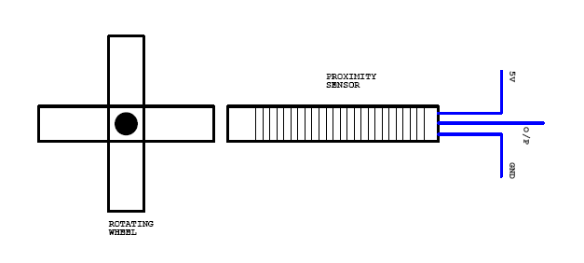
Proximity sensor:
Inductive proximity sensors are widely used in various applications to detect metal devices. They can be used in various environments (industry, workshop, lift shaft...) and need high reliability.
Inductive proximity sensors generate an electromagnetic field and detect the eddy current losses induced when the metal target enters the field. The field is generated by a coil, wrapped round a ferrite core, which is used by a transistorized circuit to produce oscillations. The target, while entering the electromagnetic field produced by the coil, will decrease the oscillations due to eddy currents developed in the target. If the target approaches the sensor within the so-called "sensing range", the oscillations cannot be produced anymore: the detector circuit generates then an output signal controlling a relay or a switch.
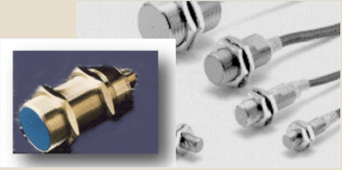
Circuit description:
The wheel type metal rod is fixed in the motor shaft. The proximity sensor is placed near the shaft. When the shaft is rotating, the metal rod is crossed the proximity sensors sequentially. So the sensor gives the pulse to the microcontroller. Now the microcontroller counts the pulse. By using this pulse count we can find revolution per minute which is equal to speed of the microcontroller.

